**FOR IMMEDIATE RELEASE **

The Bulldogs Have a Great Double Header

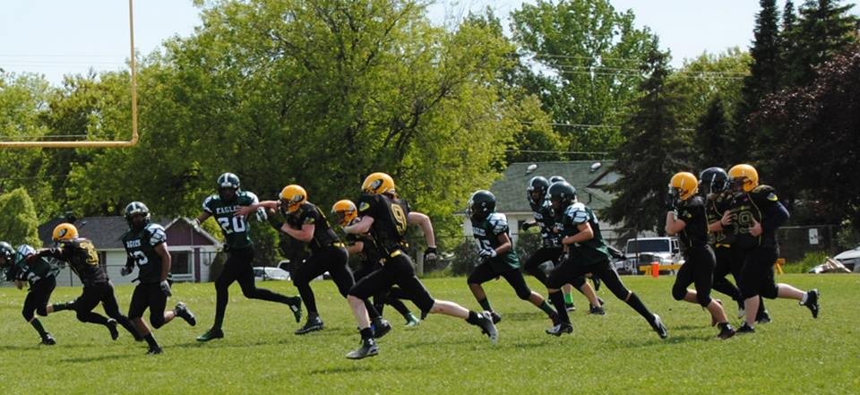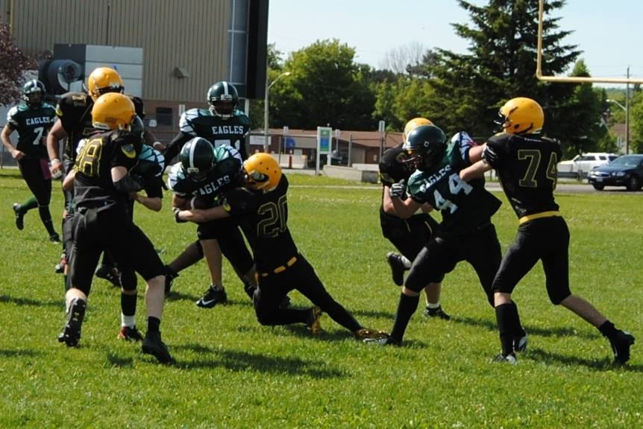
After earning their first ever road win 2 weeks ago in Oshawa, the Junior Bulldogs were back in action this past Saturday in an effort to earn their first winning record since launching the program. They got their 2nd win last week by way of default due to a set of unfortunate circumstances keeping a number of Hamilton Steelers players from being able to play last week. “Our kids were really ready to play…so this week’s game comes with great anticipation for the players and they want to earn their winning record”, said Head coach Marc Mathon before their kickoff against the Etobicoke Eagles
The Eagles come to North Bay also looking to extend their winning record to 3 – 1 after beating the defending Champions Orangeville Outlaws and the Hamilton Steelers. The Bulldogs worked hard all week on preparing to defend the powerful outside running game of the Eagles. “They have been averaging close to 200 yards per game just on outside runs, so they’re pretty good at it. We felt that if we could limit their success outside it would put us in a good position to compete with them” said Mathon.
The game opened with the Eagles running back scoring on an electrifying 79 yard outside run play to draw first blood. With the Eagles leading 6 – 0 after only two plays the Bulldogs saw the speed they were dealing with. “We gathered the defense and simply said that with fast teams, we need to corral them and pursue and tackle to the whistle.” Said Mathon.
On the ensuing series the Bulldogs Offense showed it can move the ball as well. On the strength of sharp execution the Bulldogs drove 25 yards and on the 5th play of the drive Evan Desrosier scored from 41 yards out. With Jonathan Warren convert the Dogs found themselves in a good game leading 7 – 6.
With the game looking like it was going to be a high scoring shoot out the Dogs defense showed its preparation for the Eagles and shut them down for the rest of the half limiting the Eagles to on 70 more yards of offense. In addition the Dogs defense caused and recovered a fumble on the Eagles 35 yard line. This field position set up the Dogs 2nd score. After seeing Ryan McColeman carry the ball earning some hard faught yards to get to the 17 yard line, Parker Raymond found an seam and scored on a perfectly executed outside run.

Still in the first half the Dogs maintained control of the Eagles running game and kept their offense scoreless. Meanwhile the Dogs offense continued to gain yards ending with Evan Desrosier scoring his second TD on another well executed play.
Later in the second quarter the Dogs were in the red zone again but a penalty pushed them back out and leaving them with a field goal attempt that Jonathan Warren hit perfectly. The Dogs found themselves at half time with a 24 – 6 lead and in control. “We reminded the kids that at the provincial level competition we cannot let up because they will adjust and could come back and score 3 TDs very fast.” Said coach Mathon.
To open the 3rd quarter the Dogs showed a completely different offensive package and drove 40 yards to set up a 23 yard scoring run by Anthony St Jean. After Warren’s successful convert the Dogs led 31 – 6. The Eagles opened things up with trying to pass and did complete a long throw over the middle to convert a 3rd and 30, the Bulldogs defense held their ground and kept them out of the endzone.
The Bulldogs offense finished the game with a strong showing seeing Anthony St Jean score his second major from 21 yards out. With this strong defensive game and good execution on offense the Bulldogs improve to a 3 – 1 record as they prepare to play the league’s defending Champions the Orangeville Outlaws next Saturday at 4 pm. “We have a coaching staff that focuses on teaching and they are developing into a sound coaching staff. Our coaches are a very positive group. The kids are learning and applying what we are teaching….it’s great to see…next week is our biggest test and we have lots to work on this week.” Explained coach Mathon.
In the first game of Saturday’s double header, the Bantam Bulldogs took on the TNT Express from Barrie. The game was hard fought with TNT coming to North Bay with a strong squad of veteran players. The TNT Express program see their kids start at 9 years old and these Bantam players already have 4 or 5 years football experience in the league. The Bantam Bulldogs are in their first year of competition and they are performing well as they compete to the final whistle in every game.
The 1 – 1 Bantam Bulldogs fell behind early to the TNT Express trailing 24 – 0 at the half. The second half was strong for the Bulldogs as they completed an outstanding 40 yard pass with Carson Cleator on the receiving end of the pass. The Bantam Bulldogs followed that great play with a 28 yard run by Trey Anthony to get the Bantam Bulldogs on the board. In the end the Bantam Bulldogs fell to the powerful TNT Express by a score of 30 – 6.
“These kids are awesome! In our first year at the JV level we lost every game by an average of 40+ points and we didn’t win any games. These kids won a game and scored in every game so far. We are very happy with the progress of our Bantam kids.” Said Coach Mathon
Football is alive and well in North Bay with the Bulldogs featuring a double header next Saturday, June 13th with the Bantam Bulldogs taking on the Bantam Outlaws at 1 pm and the JV Orangeville Outlaws taking on the Junior Bulldogs at 4 pm at Omischl. “I think our double header football events are a great way to spend a Saturday afternoon for football fans and the BBQ tailgate party is the best in the league!” said Mathon.

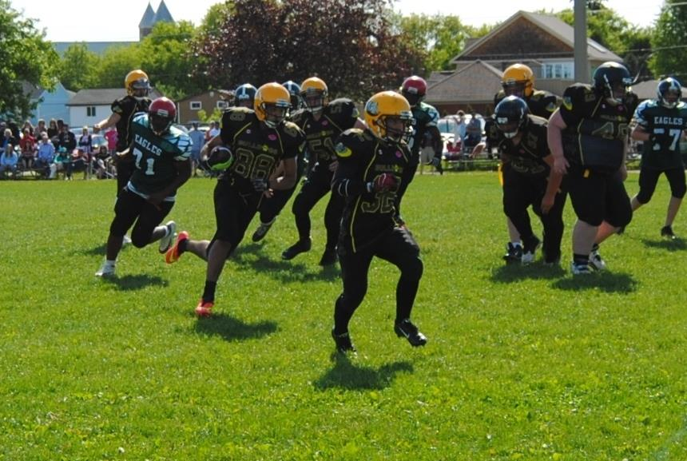
Rushing Receiving TDs
Anthony St Jean | 69 |  | 2
Evan DesRosier | 59 |  | 2
Parker Raymond | 51 |  | 1
Ryan McColeman | 32 | 15
Josh Ahola | 10
Griffin Assance-Goulais | 17
Jon Warren |  | 10
Passing
Mason McGriskin 3 completions in 8 attempts for 25 yds and 1 INT

